Why Markets Can’t Be Predicted Accurately On Any Timescale

Introduction:

There is something so utterly enticing about predicting stock market movements. Tens of thousands of individuals [XXXX] and thousands of firms [XXXX] try their hands at picking winning and losing stocks every day, buying and selling options contracts and credit spreads, analyzing candle stick patterns (as if past random numbers could foretell future random numbers), and generally failing at this endeavor en-masse. The cries of joy and shrieks of pain and missed opportunity are omnipresent from colleagues, friends and family. “Tesla is exploding! I’m making so much money.” “Oh man, Intel is killing me right now.” “I wish I had bought Yahoo in 1994.” They sense that if only they could learn enough about some company, then they could peer through the impenetrable fog and finally see the universe’s future laid out like a path that leads to riches. The money is there to be had, but just how to get at it eludes 99% of speculative traders [https://escholarship.org/content/qt7k75v0qx/qt7k75v0qx.pdf]. The reason is simple: daily, weekly, even monthly fluctuations in any stock market are nearly perfectly random. We can readily say that over the long-term, shareholder returns will increase and therefore we can be reasonably assured our retirement portfolios will be ready to deliver when we need them decades hence. But the shorter and shorter the time horizon, the more manic and less rational the market movements become. I’ll even demonstrate later that using market movements to employ rules-based trading strategies fails in long-term portfolio management over 99% of the time.

A random signal is a signal for which the properties don’t depend on the time at which the series is observed. If a section of a time series were slid over any other section, would it perfectly overlap the signal even partially? If so, when? This is the concept of autocorrelation, and the smaller the overlap, the less self-correlated and the more random the signal. The fluctuations of the stock market - not the stock market value itself - rarely show autocorrelation. In contrast, the fluctuations of a sinusoid or of monthly electricity demand - which is highly seasonal - show high autocorrelation. First it may be necessary to compute the difference of a signal. By subtracting each value from the following value, the fluctuation of each time step is revealed and the autocorrelation can be computed.

Fig. 1 - Autocorrelation of fluctuations in the Dow Jones and electricity demand.

The occasional self-correlation of stock market fluctuations is an indication of the fact that the signal is not perfectly random. The stock market, and really any phenomenon, on even short time scales won’t be perfectly random. Even random number generators on personal computers struggle to achieve such unpredictability. But to know the underlying phenomenon that explains the predictability - to see through the impenetrable fog - is nearly impossible.

Thousands of articles have been written on the efficiency of markets. The efficient market hypothesis claims that the fog isn’t a fog but a dense cloud bank with zero visibility: that all knowable information is incorporated into company valuations instantaneously and thus, no profit can be made from information. In a world where are traders are acting quickly to pounce on even a slightly profitable nugget of knowledge, a trade is made, the price is adjusted accordingly, and the profitability is wiped-out for everyone else. Tens of thousands of institutions and more individuals are all acting accordingly, so prices always fully reflect all available information, all profits are captured, and therefore no profit can be made from information-based trading. This hypothesis has been debated for decades. Instead of further debating it here, let’s look at the type of randomness - or the noise - found in the stock market’s fluctuations.

Markets are Noisy:

“Figure 2 displays a few representative examples from physics, biology, neuroscience, and psychology, to which we will refer in what follows. In both figures, power spectra are plotted in log-log coordinates, as is customary, because log(S(F))=log(constant/fα)=−αlog(f)+log(constant) . In other words, the logarithmic transform renders the 1/fα power spectrum a straight line whose slope, −α , can be easily estimated. Clearly for such natural systems, observed by humans, neither arbitrarily small nor arbitrarily large frequencies can be recorded.”

We’ve already demonstrated that the stock market is highly random in its behavior by looking at autocorrelation in the time domain. Another way of doing the same thing is to look at the power of the fluctuations in the frequency domain by computing the fast Fourier transform (FFT) of the market changes.

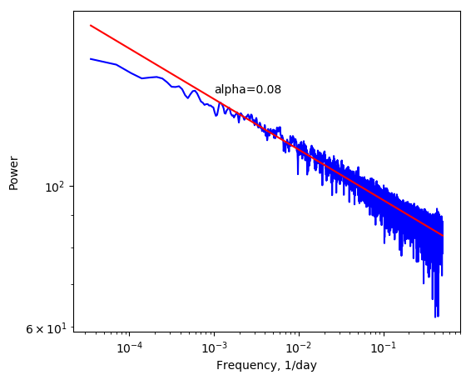

The power follows a 1/f^{α} model, where α = 0.08. This is akin to white noise. Just as autocorrelation showed us the fluctuations rarely display self-similarity, the power spectral density does the same. There is no indication of particular frequencies containing more or less power than expected. Had there existed a peak in the data that went significantly above the trendline on the log-log plot, we could use this frequency to infer periodicity and make predictions about the markets. For example, if there were a peak in the PSD at 1/0.02 = 50 days, this would indicate that some unknown trend in the data repeats every 50 days. Further inspection of the data to learn what the trend is would allow for more accurate forecasting.

A Demonstration of the Fog:

By definition, the demonstrated unpredictability of the markets implies that the markets don’t follow any simple rules based on past behavior. At no point could a speculator reasonably say, “The market has closed down by more than 5% three days in a row, therefore it will close up tomorrow by at least 10%.” Yet this sort of rudimentary logic is used by traders routinely in comments sections of investing websites. Let’s put it to the test.

To do so, a monte carlo simulation is a useful method. Using past Dow Jones daily closing data, rules of buying and selling the index can be varied and tens of thousands of unique combinations can be simulated. Each variation is a single trading rule played out over the 107 year course. Each trading strategy looks at the rate of change of the market and makes a sell-up buy-down or sell-down buy-up decision on that basis. One sell-then-buy strategy might read, “if the DJI falls 2% over 30 days, sell 5% of the portfolio value, then wait for the market to increase 3% over 10 days, at which time buy with all of the cash-on-hand from the previous sale”. This would be a sell high, buy low strategy, and it’s something every speculative trader attempts to do. Out of curiosity, the opposite strategy - sell low, buy high - is simulated as well.

The strategies must always sell first then buy because our trader doesn’t have money from a job or inheritance to invest. The reason for this simplification is because adding extra cash-on-hand periodically for investment doesn’t change the probability of a strategy beating the market. Just because a trader has more or less money to bet on a coin flip doesn’t improve the odds in one’s favor. These simulations rely purely on timing the market. The trader starts with a lump sum invested and, in good ol’ American fashion, tries to pull oneself up by the bootstraps by growing that initial investment over many decades to beat the market. By testing tens of thousands of sell high, buy low and sell low, buy high strategies on the DJI data itself, a picture emerges of the success a trader might have if he or she had started trading some kind of index fund that tracks the DJI. For now, we’re assuming zero transaction costs because most mutual funds [Check difference between mutual funds and index funds] that track the total stock market - those offered by Vanguard, Schwab and Fidelity - have no transaction costs and nearly zero expense ratios. For example, a portfolio of $100,000 entirely held in would Vanguard’s Total Stock Market Index Fund (VTSAX)) has no transaction fees and would impose a $40/year for operating the fund. This is purportedly less than the average US citizen spends on coffee in two weeks, so we ignore it. [https://www.fool.com/retirement/2018/01/22/one-third-of-americans-spend-more-on-coffee-than-o.aspx#:~:text=Acorns%20reports%20that%20the%20average,to%20roughly%20%2492%20a%20month.]

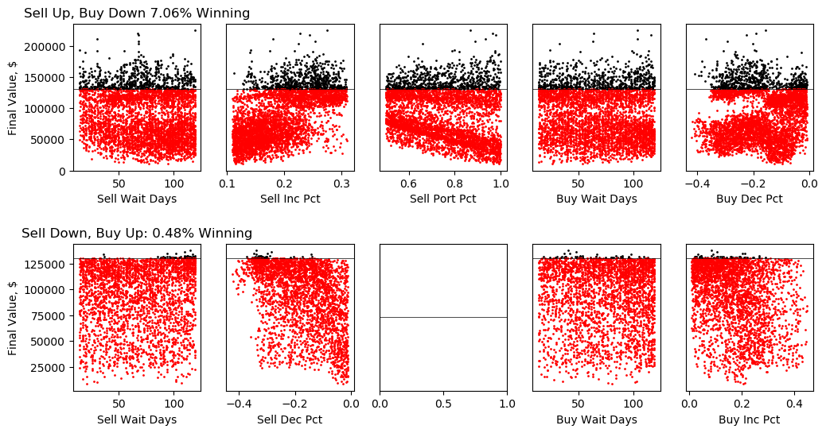
Ten thousands simulations were run for both types of trading strategies. The sell high, buy low strategies with their final portfolio values are plotted in the top row, and the opposite strategies are in the bottom row. The black horizontal line in each subplot represents the final value of the portfolio in which the trader put the money into the market at the beginning and didn’t touch it. The black points are the strategies that fall above this line and therefore beat the market. Those in the red lost to the lazy, no-transaction strategy. At first glance, we see a lot of red. Sell high, buy low, as expected, outperforms the opposite strategy, beating the market 7% of the time. This isn’t half bad, considering that only 1% of day traders - people who use chart patterns like we are - beat the market in the long run [XXXX]. Buy high, sell low wins not even 1 in 200 attempts. If a trader wants the thrill of actively investing, it pays to wait for the market to go up before selling, then drop before buying.

Let’s make sense of these plots. Each point in the sell high, buy low plots has a sister point in every other plot. For example, in the upper left subplot, the best strategy - the one with the largest final value - is $224890.87 for which the number of days the trader waited to sell was 119, about 4 months. This wait, combined with an increase in the DJI points of 27.5%, triggered a sale of 87% of the portfolio’s value before a waiting period of 104 days and a decrease of 15% triggered a stock purchase with all of the money from the previous sale. This strategy has a point in every subplot, and it’s the largest final value, circled in green.

While 16% of sell high, buy low strategies win, there is no clear group of strategies that win. That is, each winning strategy has a nearest-neighbor strategy that loses. The evidence for this is the inability of a k-means clustering algorithm to distinguish winning and losing strategies on the basis of the parameters. Specifying two and five clusters results in equally poor separation of the two groups.

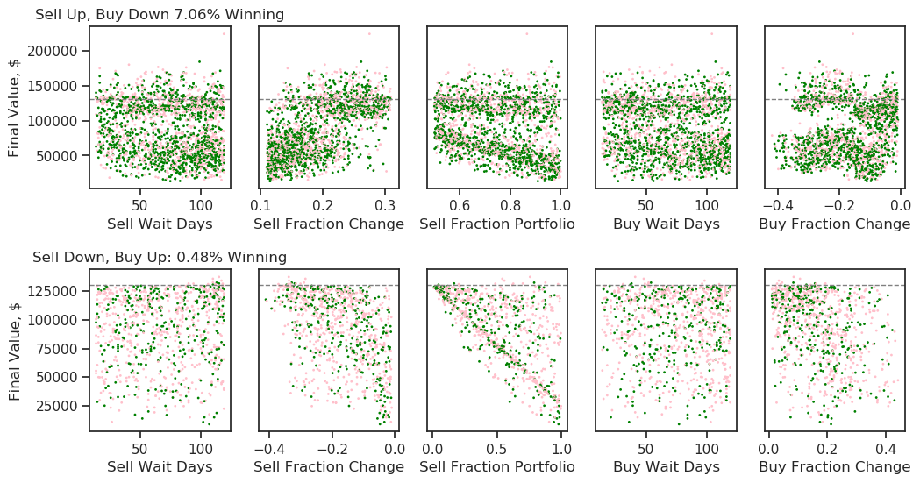

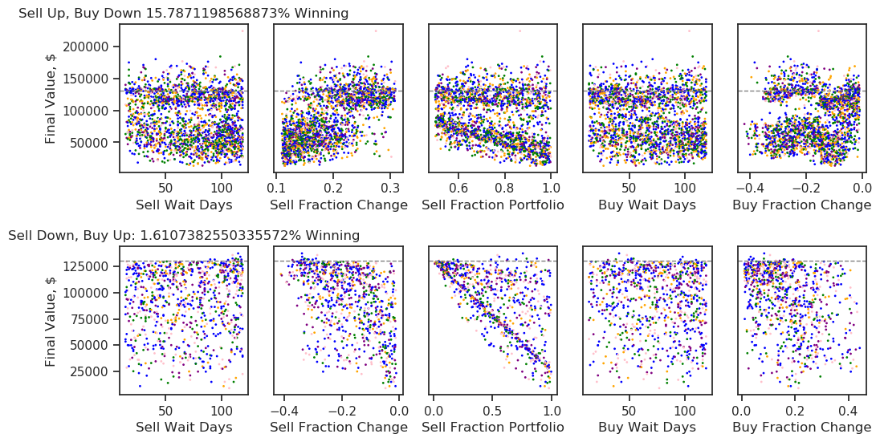
The winning rates for both strategies shown above are generous. The datasets have been cleared of any strategies that failed to generate a sell or buy event because the parameters chosen were never encountered in the history of the Dow Jones. For sell up, buy down, the true winning percentages are 7% and for sell down, buy up, 0.5%. Even more unsettling are the ways in which some strategies won. XXXX% were strategies that timed the market well early in the simulation - during the Great Depression - and then didn’t trade again. This raises the question of the relationship between time in the market and the final return. The correlation between these two variables is XXXX%. Also is the effect that number of trades has on the final return, where one trade is one sell-buy pair (the two always go together in the simulation). The correlation here is XXXX%. We’re starting to paint a picture of the difficulty of timing the market. Success depends on 1) correctly timing the market and 2) doing so early on - the earlier the better - and then keeping money in the market. Keeping money in the market for the longest possible time is, of course, anathema to the entire strategy of timing the market. Based on our two criteria, it does no good to correctly time the market a handful of times but have money on the sideline most of the time while it misses out on gains. It also does no good to time the market well as retirement nears. A long-term premium is paid to realize short-term gains that is reminiscent of Einstein’s adage, “Compound interest is the eighth wonder of the world. He who understands it, earns it. He who doesn’t, pays it.” For the investor looking to profit on short-term market movements, almost all trades lose money [XXXX Percentage of trades that make money and lose money]. A few trades make money. This fact is further exemplified by the average percent change in the market for different time periods from one day to thousands of days: it’s always positive.

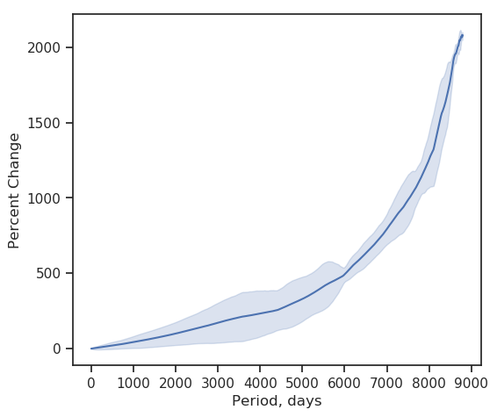

Shading is +/-1 standard deviation. For even small periods - those under one week - the average change in the market is positive. If a trader put money into the market just before close and sold the next day at the same time, this person would make money with this strategy repeated on random days over many years and assuming no transaction costs. The data above was used to choose reasonable parameters for the simulations. It doesn’t make sense to run a simulation that requires a doubling (100% gain) of the DJI over one day in order to make a trade, but it does for a period of five years.

Looking at the maximum and minimum percent change for different periods shows that any period over 6950 days is always positive, and the maximum percent change has reached as high as XXXX% over a period of XXXX days [Plot the min and max percent change data]. If an investor held money for any 19 year period in a fund that tracked the Dow Jones then the investor was guaranteed to make money, ignoring inflation’s effects. Taking inflation into account, the minimum period to make money is XXXX days.

So which individual strategies make money? The highest performers are ones that correctly timed the Great Depression, selling near the peak and buying near the bottom, never to transact again. The Great Depression was unique because it resulted partly from a lack of government regulation of the markets that has since been remedied. The market no longer ebbs and flows exactly like it did in the early 20th century. Such winning strategies were one-trick ponies, capitalizing on a transient phenomenon. This method of a few small trades over a lifetime or longer is psychologically difficult to execute and would require coordination with one’s heirs who would eventually be responsible for the portfolio.

Other strategies that were less successful include...

To conclude, the investment strategies explored here ranged from capitalizing on market movements over a single day to trends over many years. Despite the massive range of parameters, all strategies attempted to either make money buying on the upswing and selling on the downswing, or vice versa. No strategies attempted to buy and sell on the upswing, nor both on the downswing. This might be one criticism of this work. It’s possible that rapid changes in the market might have a tendency to be followed by smaller changes in the same direction. A rapid decline followed by a small decline as the market stabilizes is one example. Then again, given what we’ve seen, why would this be the case? Few market-beating strategies have neighboring strategies that also succeed. Thus, for every big-then-small decline, a big decline then small gain (a dead cat bounce) is just as likely if not more likely, given the positive direction of the market in the long run. There are still more complex patterns not explored here. It’s worth asking if basic patterns don’t emerge as successful, would more complex patterns be enlightening? It’s likely that if head-and-shoulders patterns are meaningful, then different buy-sell strategies would identify these because it’s a rise-plateau-fall behavior that occurs on one timescale. Thus, one strategy would hit on just the right combination of parameters to sell on the plateau and buy after the fall. If after a sharp change in value there is a slow exponential decay or growth, buy-sell strategies would still find a way to profit because it’s a decline (or increase) on a short time scale, followed by growth (decay) on a longer timescale. Even head-and-shoulders and exponential patterns overlaid onto themselves and each other should give rise to increases and decreases in the market and be made profitable by simple buy-sell strategies. Nonetheless, few individual investors are interested in, nor have the time for, the complex mathematical fitting of functions to stock charts. Most want a simple strategy to follow so they can retire and not be so cash-strapped that they’re forced to eat Alpo. No such strategies exist. Only luck - few people have it - and time. And the best time to invest was yesterday.

Why do the vast majority of strategies fail to beat the DCA strategy? After all, if the market goes up or down, wouldn’t a coin flip guess correctly half the time, and thereby beat the market half the time[XXXX XKCD comic on this]? The answer is no, and the reason is due to opportunity cost. Every moment money isn’t in the stock market because shares were sold is time during which that money misses out on any stock market movements while a trader waits to buy at the right moment. Because the market has gone up over the long term, having money out of the market for any period of time is generally a losing strategy over that time period. More precisely, it’s a losing strategy about 84% of the time. The best time to invest was yesterday.

More complex strategies could be simulated that utilize head-and-shoulder patterns, intraday patterns, etc. Ideally, a trader needs a strategy that beats the market over 50% of the time for it to be worthwhile, much like a card counter requires a 52% winning probability - a 2% advantage on the house - when gambling at blackjack. There’s no fundamental reason to think that any complex pattern will improve the winning odds by 16 times ((0.52 / 0.48) / (0.07 / 0.93)).

Attempting to cluster the data into winning and losing groups doesn’t work:
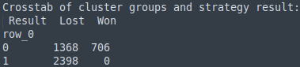

All of the winning strategies are in a single group - group 0 - but many of the losing strategies are also in that group. If we try three clusters...
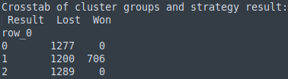

The winning and losing strategies don’t fall into separate groups despite using more clusters.
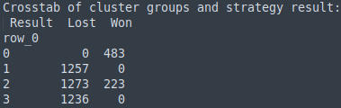

With four groups we get 0 (all winning) to separate from 1 and 3 (all losing). Group two is a mix of mostly losing strategies.

Let’s observe the stock market at different time scales around a specific data: 1975.

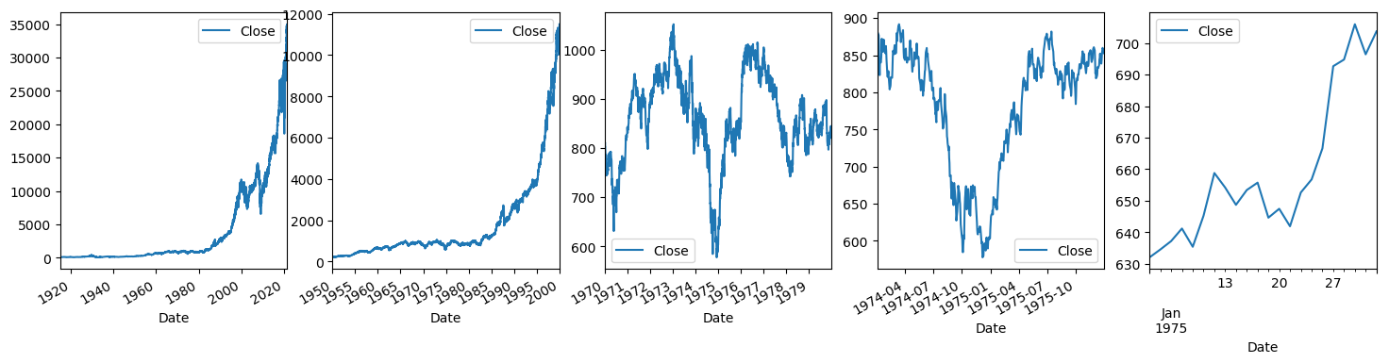
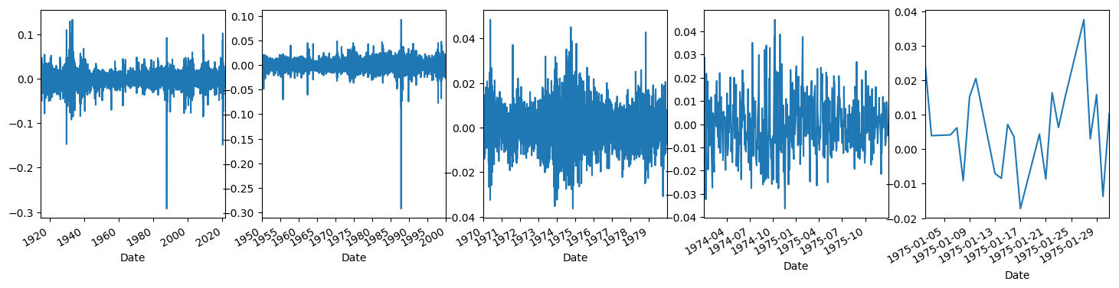

The stock market is not self-similar, like the Sierpinski triangle, but self-affine. The effect is that to look at different scales does not produce an identical level of detail but instead produces a lengthening in one axis. For stock market movements, a decades view has few large fluctuations, a weekly view has more and a daily view has many. Thus, the stock market looks slightly different at various timescales. Below is the Dow Jones Industrial (DJI) index daily closing prices from 1985 to 2020 viewed at different timescales and its power spectral density.

The spectrogram shows the power, or amplitude, for a large range of periods from one day up to 17.5 years. The DJI daily closing price data covers 35 years but the FT can only use half of the maximum time period. Notice the lack of prominent peaks. If there existed dominant frequencies they would lend some predictability to the market that could be used by someone, then by everyone. Furthermore, there is a linear slope to the power density, meaning the power spectral density is approximately 1/f, the hallmark of flicker noise. More precisely, it’s c/f^{alpha} where c is a constant and alpha is between 0 and 1. For purely stochastic fluctuations, alpha is one. alpha of 0 is [XXXX], while alpha of 1 is pure flicker noise [XXXX]. The flicker noise derives from phenomena that don’t follow a Gaussian or bell curve probability distribution (think of human height, blood pressure and IQ) but instead follow a power law. A power law describes any phenomenon for which the number of events is inversely proportional to their size. These events are familiar: most asteroids that hit the earth’s atmosphere are small, the medium ones less frequently, the bigger ones even less so, and the largest extinction-level ones are beyond rare. Likewise for the number of earthquakes and their magnitudes, as well as the fluctuations in many events such as river level, bacterial chemotaxis, thermally driven micro-cantilever oscillations and resistor voltage noise. The stock market’s price changes follow the same pattern. The smallest changes are the most common, while the largest are rare enough that they might happen once in several decades. The largest DJI price change in one day was -29.2% on October 19, 1987. The second largest daily price change of +9.9% occurred almost 21 years later on October 13, 2008. The figure below shows the power law. In theory it should be perfectly linear but in practice the plot plateaus in the regime of the most frequent, small events. This is due to the fact that power law phenomena and by extension 1/f noise are the sums of many low-pass power spectra, all of which have overlapping linear regions and non-overlapping plateaus on the log-log plot. Fitting the 1/f^{α} model to the power spectrum of the Dow Jones results in an alpha of 0.08. This indicates white noise with a δ-correlation function.

Machine learning approaches to predicting random stock market fluctuations have included the use of long short-term memory recurrent neural networks. This algorithm reliably converges on a solution that uses the previous day’s closing price to predict today’s closing price. This is of course an absurd solution and its accuracy is usually slightly under 50%, or worse than a coin toss. These models, generated by the lay person and not a multi-billion dollar hedge fund, do not use fundamental market data but instead the previous closing prices to predict future prices. It would be difficult to predict even the voltage across a resistor this way.

Despite everything discussed so far, let’s run some monte carlo simulations of investment strategies in the hopes of timing the market. This is something people try to do on there own, and here are some examples:
“The market has gone up two days in a row now, it can’t possibly go up tomorrow, right?

History:

Attempts to predict stock market returns go back to [YEAR] and span rudimentary approaches like fundamental analysis (looking at P/E and market cap to GDP ratios to understand a company’s value), technical analysis (analyzing candlesticks and ignoring company valuations) and machine learning (recurrent neural networks and genetic algorithms that also use previous trends and ignore company valuations). These methods have not become more efficient over time.

Stock Market Fundamentals:

To make accurate predictions, it’s necessary to have variables that correlate with the outcome of interest and preferably do so in a way that leads the outcome in time; so-called leading indicators. Learning of the variables that correlate with prices can be difficult. Does the weather predict prices? Yes, but not to a degree that reaches significance [XX]. What about long-term climate? Perhaps a country’s consumer demand for housing, export volume, current oil reserves, elements of future agriculture productivity such as drought, and mining output of raw materials. Consumer psychology and health is known to play a role. What about other developed economies? China undercuts prices on goods intentionally [XX], and surely this can affect shareholder returns. It’s possible that it’s not necessary to have this level of granularity and instead rely on aggregate numbers like gross domestic product and the consumer price index. But everyone has access to that data, nullifying any competitive advantage. We could envisage an endless arms race between thousands [XXXX] of hedge funds all trying to gain access to ever more granular, precise market information until they’re measuring the quantum states of all physical matter. If that were possible, just how much farther could they peer through the impenetrable fog?

It turns out it likely would not. [XXXX this section can go on about different phenomena and their predictability]

The Stock Market is Noise:

The problem has a fractal, or self-similar, feel to it. Like any fractal, zooming in doesn’t help. I mentioned the possibility of agricultural yields on stock market value growth. Let’s try zooming in on this industry. The use of glyphosate weed killers and glyphosate resistant crops began in 1995 and increased until 2005 then flattened. This decimated many pollinator friendly plants that once grew well in the tilled ground between rows of crops and at farm boundaries, including milkweed, a particularly annoying plant for farmers but the monarch butterfly’s singular host plant that without the species will go extinct. With non-revenue-generating plants out of the way, monarch populations declined by [XXXX]%, bee populations declined by [XXXX]%, and wheat and soy yields improved by 50% [XXXX]. This is an explosive increase in productivity. Everyone knew in 1994 that Monsanto’s technology would improve crop yields, increase shareholder returns, and decrease pollinator numbers in areas where it was used. That information was rapidly priced into the market and shareholders saw their portfolios inch upward. But this may be where the predictive capacity ends. When will the next plateau-busting technology emerge and what will it be that will increase crop yields even more? Zoom in further: Monsanto, XXXX, XXXX, and other companies are working on competing technologies in similar and different ways as well as their own proprietary technologies. When will these be successful enough to be sold and used widely? XXXX is working on biofertilizers that will alter the ecology of the soil on farms and, if they work, will eliminate the need for many fertilizers [XXXX check this]. Will such technology be successful? If so, would it dominate the market and displace the need for products that incumbent companies like Monsanto are working on now? Or will the product fail completely? Zoom in further: In the laboratories of Monsanto at this moment, scientists are running experiments to advance the in-house technology. Maybe the scientists are trying to get wheat cells to express a gene, so they need to get the gene into the wheat’s genome, but it’s not working. Eventually they figure out how to get the gene transfected, they then need the wheat to produce in large quantities the protein it codes for. Maybe the protein is an eflux pump that ejects a new weed killer from the cells so the plant is resistant to a new kind of weed killer the company is developing simultaneously. Now the protein is being produced but not in sufficient quantity to allow the plant to survive given the expected concentration of weed killer it will encounter. Perhaps they finally land on the correct gene sequence to maximize the protein’s production but it’s not translocating efficiently to the cell membrane where it does its job. The protein has a transmembrane domain and should, in theory, be placed by the cell’s machinery in the cell membrane, but alas the company’s scientists don’t know everything about how the wheat cells are post-translationally modifying these eflux proteins and likely that is where the solution is to be found. One day, after a few years of working on this technology, they solve the problem, only for the government to announce, in response to public outcry over catastrophically low pollinator numbers that herbicides and insecticides can’t be applied on more than 5% of farm land. The project is killed overnight and billions of dollars are lost. A hedge fund would benefit from - and possibly need to know - information at the macromolecular level of wheat cells to make high quality predictions of Monsanto’s stock. Short of this, having the head scientists at these corporations sell information about the real-time success or failure of thousands of such experiments, or the expected probability of success of all research endeavors, would be beneficial but also a violation of antitrust [XXXX] law. Thus, the information required can’t be legally known. If it could be known, the data would have to be incorporated into a predictive model so future projections could be made. Just because it’s difficult doesn’t mean it shouldn’t be done, as the model would only have to be slightly better than competitors’ models for it to be profitable. Then all it takes is for a unit impulse to appear completely out of the blue to ruin all predictions. At the beginning of the coronavirus pandemic, machine learning models that predicted consumer demand failed overnight as demand for toilet paper, N95 masks, gasoline and other consumer goods instantly skyrocketed. Understandably, the models hadn’t taken into consideration the consumer psychology of global pandemics. They had to be modified [XXXX need to read how this was done] to ensure distribution of goods was in sync with consumer demand.

Around every corner there is either a pot of gold, a bogeyman, or both. Success or failure depends on the types of phenomena you choose to predict and how responsive those predictions are to improved information quality. Some phenomena - weather, double pendulums, etc [XXXX] - are incalcitrant, while others - golf scores, etc, etc [XXXX] - are highly responsive. The difference is in the degree of chaos. Chaotic systems like weather or a double pendulum will all-too-readily reach a bifurcation point and zig or zag in a new, unpredictable direction. A golfer’s scores are more tractable because they lack some chaotic internals [XXXX is this even a fair comparison?]. And tomorrow we can just about be guaranteed of the sun’s time and place of rising and setting.

The challenge of stock market prediction is multi-faceted and impenetrable:
1. Stocks movements are almost perfectly random.
2. Due to this randomness, a very granular set of data must be obtained that correlates with stock movements. This dataset will likely be difficult and expensive to obtain.
3. Once the challenge of obtaining a good dataset is overcome, the competitive advantage it offers is time-limited, as other well-healed, talented institutions will eventually unearth similar methods and gain a foot hold. If a particular firm attempts to specialize in the collection and sale of these data to hedge funds and other investors, they will struggle for business once all investment firms have the data and no longer have an advantage over one another. Even worse: new, market-moving variables that were previously worthless reveal themselves, while previously useful variables become temporariliy or permanently unreliable predictors. The revelation that reddit users were driving GameStop stock is one example of this. This process injects unpredictability into the markets, bringing us full circle.

Watch a butterfly fly. Can you predict its path in the next 5 seconds? You know it may generally head toward flowering plants in the vicinity, but only with a certain probability, but it might not. Just as we may know the stock market will increase over time with some probability, but it might not. Even if you could measure the states of all of the neurons in a butterfly’s brain (which you couldn’t), and then input this information into a model of its brain so that you could know its future state, and predict its future flight path, the problem becomes a nonlinear dynamical one - like the weather - in which you can only predict up to a point in the future. That point is the bifurcation point, beyond which predictions have to be recalculated to be useful. The time into the future varies depending on the phenomenon. Electricity demand is about a year [XXXX check this], the local weather is about a week, and a double pendulum deviates from predictions within a couple of seconds of its release. Increasing knowledge of the system state by one million times increases predictive capacity by ten times [XXXX check this]. With the high cost of measuring the factors that drive markets in the short term, individuals and companies are better off putting their on a roulette wheel [XXXX check this]. Why they don’t is a mystery to me. As individuals, we can rest assured that our retirement portfolios will outperform every hedge fund over a 10-20 year period [XXXX check this] and 99.X% of individual day traders will lose money within one year [XXXX check this].

